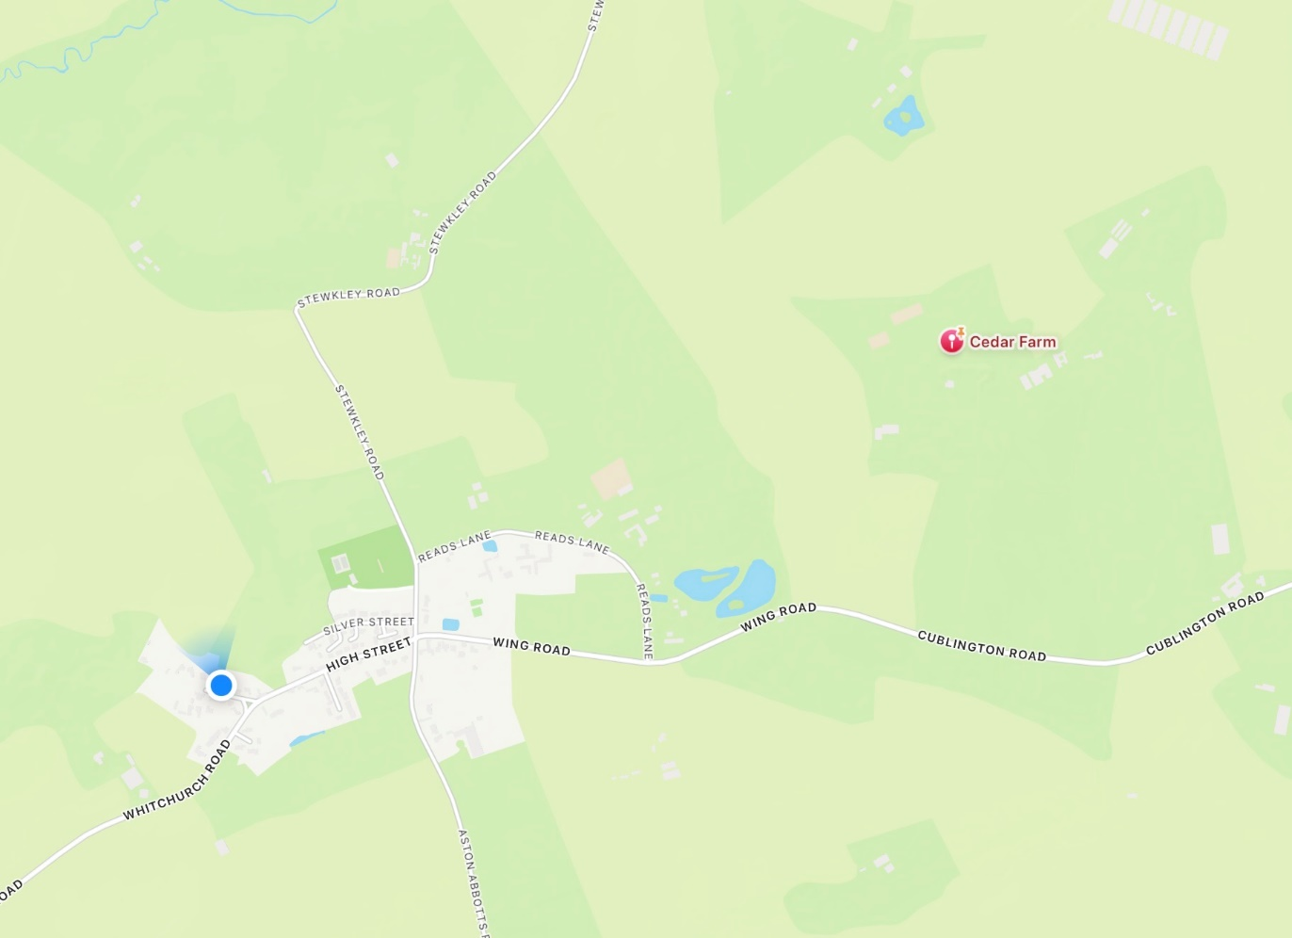

Cedar Farm, Cublington Road, Wing -
HGV Operating Licence Application

We have had our attention drawn to an application for an Operating Licence at Cedar Farm, Cublington Road, Wing. The application is for the operation of 24 HGVs and trailers. As a Parish Council we are extremely concerned about this proposal.

Parish Councils are among those groups who may not object. Buckinghamshire Council is permitted to object, and the Parish Council has drawn the attention of our Ward Councillors to the application and shared our concerns with them.

However, individuals who live in the vicinity of the proposed centre may make representations against the proposed licence. The following information is taken from this site:

Office of the Traffic Commissioner - A Guide to making representations, objections and complaints - GOV.UK

Unfortunately, we were only alerted to this issue very recently and the closing date for making representations is next Tuesday - 24th February.

Who can make a representation?

“Owners and occupiers of land or buildings within the vicinity of an operating centre who feel that the use or enjoyment of their own land would be affected by the proposed operating centre.”

There is no clear definition of “within the vicinity” – the representor must state how they are affected. Due to the distance from the site, some Cublington residents will fall into the category:

“the use of my land or property will be affected by heavy goods vehicles travelling along a public highway”

How do I make a representation?

By post or email. This is a link to the form for making a representation: 111124_Annex_3_Template_for_making_representations.odt
It is not compulsory to use this form, but it gives an idea of what information should be included in a letter or email.

A partially pre-populated form is also available here.

What do I have to include?

You must describe the grounds for making a representation.
Generally speaking, a traffic commissioner will consider the effects of:
- Noise – from the applicant’s vehicles moving in and out of, and while at, the operating centre. This may be intrusive in the neighbourhood, bearing in mind the use of other land in the surrounding area and the intended hours of operation;
- Visual Intrusion – the effect the parking of vehicles at the operating centre may have on the outlook from a representor’s property or land;
- Vibration/disturbance – the effect vehicle movements may have, either at the operating centre or on their way to or from the operating centre;
- Fumes/Pollution/Dust etc – the effect of fumes from the applicant’s vehicles on the use or enjoyment of property.

The guidance states that a sketch map is also helpful.

Where do I send my representation?

Representations can be submitted electronically but must be signed (i.e. not anonymous), and a copy must also be sent to the Applicant (Eurolink UK Ltd).

Address of the Traffic Commissioners for email or postal representations –
By email: Environmental@otc.gov.uk
By post to:
Environmental Team,
Office of the Traffic Commissioner,
Quarry House
Quarry Hill
Leeds, LS2 7UE

You must also post a copy to the applicant (failing to do this will invalidate your representation):
OF2054483 Standard International
EUROLINK (UK) LTD

OF2054483 SI

EUROLINK (UK) LTD Director(s): ZEESHAN ZAFAR MALIK

30 WOOD CLOSE, HATFIELD HERTS, AL10 8TX New operating centre: CEDAR FARM, CUBLINGTON ROAD, WING, LEIGHTON BUZZARD, LU7 0LB New authorisation at this operating centre will be: 24 Heavy goods vehicle(s), 24 trailer(s) Removed operating centre: MISTORAGE, UNION COURT, GROVEBURY ROAD, LEIGHTON BUZZARD, LU7 4UX New licence authorisation will be 24 Heavy goods vehicle(s) New licence authorisation will be 24 trailer(s)

Alison Head
Clerk, Cublington Parish Council
20/2/2026

cublingtonpc.clerk@gmail.com

