Press release: July 2018

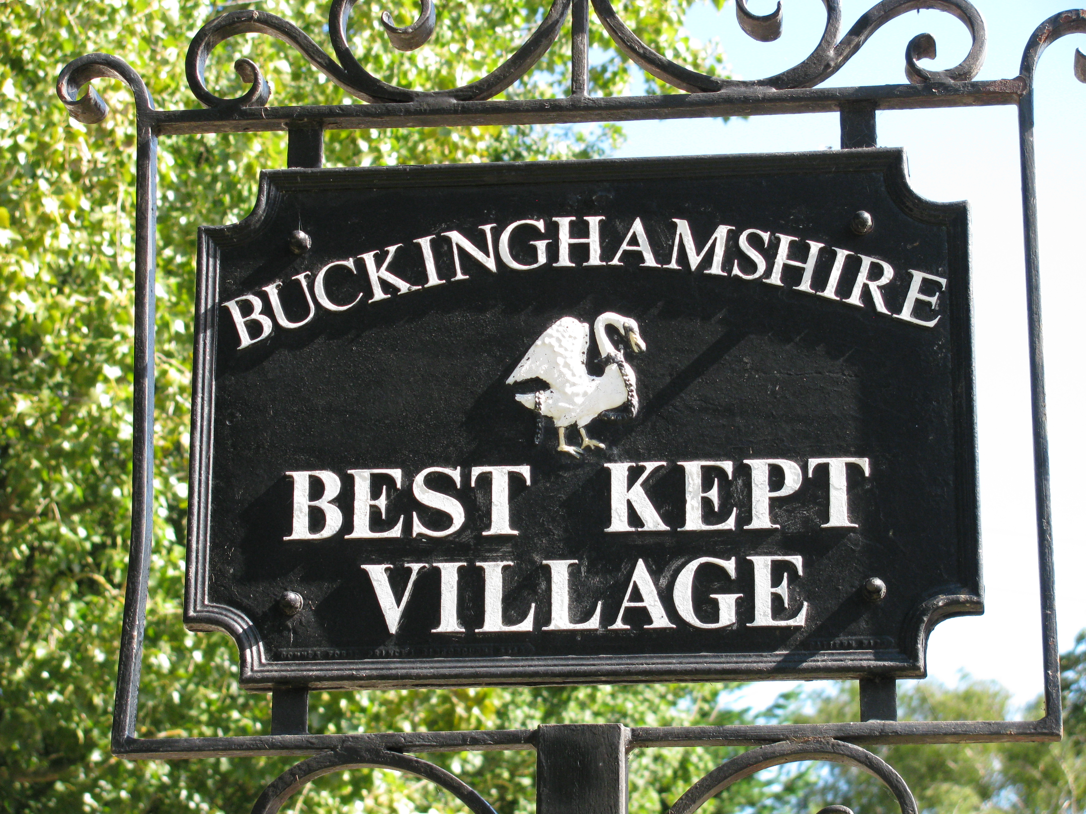

2018 Best Kept Villages Revealed

The judging of the 2018 Buckinghamshire Best Kept Village Competition has been completed and the results are now revealed:

Weedon, winner of the Gurney Cup (villages with a population of 500 and under); Chenies runner-up

Padbury winner of the Morris Cup (villages with a population of 500 – 1500);
Hedgerley runner-up

Cheddington winner of the DeFraine Cup (villages with a population 1501 – 3000);
Wing runner-up

Chalfont St Giles, winner of the Pushman Cup (villages with a population over 3000);
Haddenham runner-up

Wendover winner of the Michaelis Cup (small towns);
Marlow, runner-up

Cuddington winner of the Tindall Cup (2017 cup winners);
Stewkley runner-up

Wendover has been awarded the Sword of Excellence as the best overall winner.

The Dashwood Trophy for the best runner-up goes to Wing

Wing is also being awarded the Community Trophy

Richard Pushman, Chairman of the Best Kept Village Competition, comments: “Our popular Best Kept Village Competition highlights the great community activity that goes on in our lovely Buckinghamshire villages. It is a great way to recognise the contribution of many who give their time and effort to showcase and enhance their local environment. The Best Kept Village competition is not just for ‘pretty’ villages – we want to see communities where everyone makes an effort to keep their surroundings well maintained. The competition is a good opportunity for villages to celebrate all the positive aspects of life in their village and we warmly congratulate this year’s winners for their superb efforts.” The standard is higher than ever this year despite the drought conditions.

The Best Kept Village Competition is sponsored by George Browns and Buckinghamshire County Council with additional support from Milton Keynes Council and District Councils from Aylesbury Vale, Chiltern and Wycombe.
The cups will be presented in the winning villages by Sir Henry Aubrey-Fletcher, Lord Lieutenant on Saturday 15th September.

Further information regarding the competition is available from the Buckinghamshire Best Kept Village Competition Administrator by email at bkvbucks@gmail.com or by telephoning 07734 886540
- ends -

Further press information from: Clive Parker
tel: email: bkvbucks@gmail.com

Notes to Editors:

The Buckinghamshire Best Kept Village Competition is run independently by a committee on a not-for-profit basis. The competition has been in existence for 61 years. www.bucksvoice.net/bestkeptvillage

