RESTORING THE RIGHTS

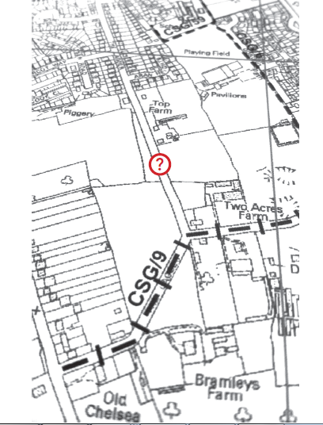

MISSING LINKS
PAPER ONE – BACKGROUND
Short version

Ross Osborn
Project Volunteer Co-ordinator
On behalf of
The Buckinghamshire Local Access Forum
September 2016

CONTENTS

What is this all about? Page 3

Definitive Maps – a very brief history Page 3

What tools will you need? Page 4

Build a list of routes Page 4

Name changes Page 5

Useful Definitions Page 6

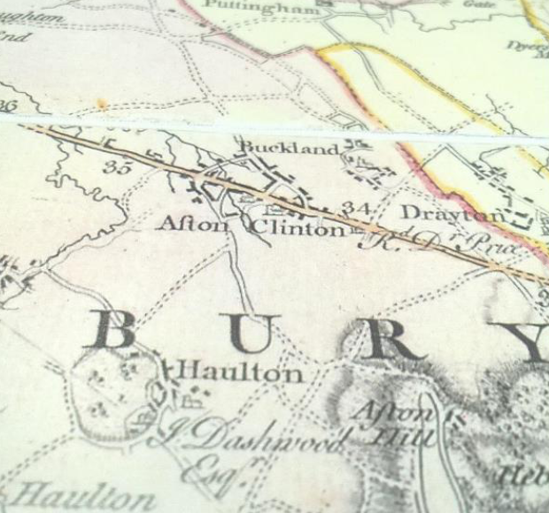

RESTORING THE RECORD or “FINDING THE MISSING LINKS”

WHAT IS THIS ALL ABOUT?
On 1st January 2026 – less than 10 years away – it will no longer be possible to use historic map and documentary evidence to claim ‘lost ways’. Any path, track, alleyway, bridleway, cut-through etc. not registered on the Definitive Map – or submitted for registration - could be in danger of being lost forever [though it might will be possible to claim some paths under the 20 years, unopposed-use, rule]. Even old and still well-used, but officially unrecorded, paths and tracks may be at risk. The ancient maxim on which many claimants have relied, in the past, “once a highway always a highway” will be history.

What does that actually mean to those who walk, cycle or horse ride along our public foot-paths and bridleways? The basic message is stark – we take our access to the countryside for granted; we use routes for recreation and as a means of linking places together without thinking but if we don’t check what we already have, or what has been used in the past, and that it is legally recorded, we could lose them and we may never get another chance to register them in future.

Simply put...a small strip of land between a highway and the start of a definitive path might be unregistered. After 2026, a landowner could put a gate or fence across it and restrict all entry to the public – quite legally – thus permanently hindering access to the countryside because we have assumed the map to be correct but not checked it against what is actually on the ground. Comments like “we have always used it” will not hold water unless the 20-year rule can be proved. It is not worth the risk!

There could be hundreds of unrecorded public rights of way across the country, with many in Buckinghamshire. If we don’t check what we have got and make amendments to the Definitive Map, it will not be just our generation which will suffer but those who follow after us and is that the legacy we wish to leave them?

There is something in this project that can involve everyone, such as taking photographs in the archives [we’ve made special arrangements for free access], studying old maps of your local area, checking your local path / bridleway network or walking local footpaths to ensure the correct signs are in place. You could, with some creative thinking, find something to appeal to everybody's interest.

Definitive Maps – a very brief history
As people became more mobile in the 1900’s, and particularly after WW2, it was realised that local knowledge about communities and their rights of way was in danger of being lost. To counter this, a governmental committee was set up which recommended that there should be a nationwide Definitive Map of rights of way so that people would know for certain where they could / could not legally walk / ride across other people’s land. That was enacted in the 1949 National Parks and Access to the Countryside Act.

Footpaths and bridleways were surveyed and recommendations were placed before parish and county councils. The parishes commented and, eventually, the counties published a Draft Map and Statement which was deposited in county archives. The results were patchy as some areas were recorded more diligently than others. The Draft Maps were commented
upon by the general public, issues were raised and resolved and a Provisional Map and Statement was produced and archived. This Provisional Map was commented upon by the land owners, amendments made and a Revised Map and Statement produced and archived.

On completion of this stage, counties could print their Definitive Map which established that in law, and at the map’s publication date, there existed conclusive proof of the right to walk, or ride, or take a carriage, according to its status across other people’s land. Those rights still exist where they haven’t been stopped-up.

The Definitive Map is continually updated as routes close or open. Printed versions are available on the seventh floor of County Hall and they are also on-line [search for ‘Buckinghamshire rights of way’]. You are welcome to study all the Draft, Provisional and Parish maps, in their succession, and even the Definitive Maps as they progressed up until today's date.

WHAT TOOLS WILL YOU NEED?

A Definitive Map of your parish can be obtained from County in PDF format for you to print off. Beware: you might have some difficulty in places like Staples because of copyright concerns. These maps are updated on a regular basis and show footpaths, bridleways, restricted byways; byways open to all traffic [BOATs] and other routes with public access [ORPAs]. Most of these are also shown on the 1:25,000 Explorer OS maps. If you come across a RUPP [road used as a public foot path], these have all been reclassified, by Act of Parliament, to restricted byways.

For everyday use, the OS 1:25,000 Explorer Maps are good as your index map and for recording on-the-ground findings. Care should be taken to ensure only the most recent map is used so check the date for which the information on rights of way applies. Some of the more recent maps include ORPAs.

We believe that there are two priority elements to this project:

A. To satisfy ourselves that the current Definitive Map – a legal document - is correct, is error free, has no omissions etc., and that the information is also correctly shown on the OS Maps – an evidential source. This element requires both ground and map based work.

The cross-checking between mapping sources is critically important for, occasionally, a right of way may be found on the OS map which doesn’t appear on the Definitive Map and it is this latter which takes precedence. The reverse may also occur. An example is the A303 road widening scheme in Somerset; here, a new bridleway had been built 20 years ago but County still haven't put it on their Definitive Map, or sign posted it. So don't think, "Oh, that's modern, that must be okay". It goes almost without saying that good research is about detail. Look at things thoroughly and
assume nothing.

B. To identify areas of doubt - ‘missing links’ or anomalies - that will require further research prior to any Definitive Map Modification Order being raised. This will need time spent researching a range of documents primarily to be found in the Centre for Buckinghamshire Studies as well as the National Archives at Kew. Where this phase is concerned, we suggest you primarily concentrate on routes which have a particular value to the wider community. These could be links between habitations, connections with national trails, promoted routes, visitor attractions, those with higher rights [bridleways and restricted byways] or resolving road safety issues etc.

Build a List of Routes

A cursory look at your parish map might indicate potential new routes to open up, identify anomalies and highlight routes that look suspicious. Here are just a few questions worth considering just in your parish:
:
1. Does the Definitive Map accurately show what is actually on the ground or have paths / bridleways been moved, changed status or not even mapped?

2. Are all public footpaths and bridleways, restricted byways, BOATs and ORPAs accurately mapped on the OS map or do some have ‘higher rights’ than that shown? For example – should that footpath actually be a bridleway or restricted byway?

3. Are there old lanes, tracks, white roads not currently used that could potentially be useful in the future? Are they on the List of Streets? [refer to BCC List of Streets]

4. Why does that footpath or bridleway suddenly end at the parish or county boundary?

5. Is the path / bridleway properly signposted at both ends and at junctions?

6. Does the shown route join the metalled highway or is there a strip of gravel not marked as a footpath or bridleway on the map between the path end and the metalled section?
First step here might be to go to the List of Streets – if this piece of track appears on the list, it’s a publicly maintained highway and you need take no further action. If it doesn’t, note it down for further investigation.

7. Is that little dog-leg where two footpath cross another track or farm track actually marked on the Definitive Map – it may not be!
8. An old map shows the existence of a path but a more modern one doesn’t....Why?

9. A footpath is obliterated by gravel extraction workings or major infrastructure works. What should I do here?
There is probably already a legally binding agreement for the footpath to be temporarily stopped-up and reinstated to its original line once the workings have finished which may be many years ahead.

10. On my map, I noticed that a footpath / bridleway did not quite meet the adjacent road and there appears to be no linking path. What should I do?
“It might be one of the missing links that we are looking for”. Check the List of Streets for an end grid reference AND check it out on the ground and take action from there.

Name changes
Beware of parish name changes. Your PDF will give the current name but the maps may show something different. Lane End PC was originally Lane End and Fingest PC, for example.

Definitions
We use definitions the whole time until they become a type of shorthand and are taken for granted. The danger is that we forget their original meaning. Rights of way definitions are no exception and we bandy terms like ‘restricted byway’ about with abandon but I wonder how many of us know the exact definition, in law, of that phrase. Fortunately, The Institute of Public Rights of Way and Pam Rumfitt Associates have produced a list of Useful Definitions which are reproduced, in part, on the next page..

Useful Definitions

Highway | A way over which the public have a legal right to pass and re-pass. All public rights of way are highways.
Public Right of Way (PROW) | A general term used to describe all types of minor highway including Public Footpaths, Public Bridleways, Byways Open to All Traffic, Restricted Byways and Roads used as Public Paths (RUPP).
Public Footpath (FP) | A highway along which the public has the right to pass and re-pass on foot only.
Public Bridleway (BW) | A highway which the public may use on foot, or on horseback or leading a horse and possibly with a right to drive cattle. The 1968 Countryside Act also allows the use of bicycles on bridleways. Highway Authorities are under no obligation to facilitate use of bridleways by cyclists. In addition, cyclists are required to give way to pedestrians and horse riders.
Byway Open to All Traffic (BOAT) | A highway which may be used by all classes of user, including vehicles but mainly used by the public as a footpath or bridleway.
Roads used as Public Paths (RUPP). | Now reclassified as Restricted Byways.
Restricted Byway (RB) | A public right of way for pedestrians, horse-riders, cyclists and those using non-mechanically-propelled vehicles (e.g. horse-drawn vehicles).
Higher Rights | Change of status from footpath to bridleway to restricted byway etc.
Green Lane | A term with no legal meaning but generally used descriptively to indicate un-metalled highways.
White Road | Tracks and lanes coloured white rather than yellow on OS maps. Many of these are now shown on OS maps but do not indicate whether public or private. However, most are publicly owned and maintained.
Other Routes with Public Access [ORPA] | Similar to White Roads. Shown on OS maps with either red or green dots. Highways maintained at public expense and are shown on the List of Streets. Carry at least public footpath rights but maps do not necessarily indicate what other rights exist over them
Metalled road | Any road or track, whether a public highway or not, to which the public has access and which has a sealed surface.
Motor vehicle | A motor vehicle is legally defined as being a mechanically-propelled vehicle (MPV) that is intended or adapted for use on the road.
Mechanically propelled vehicle (MPV) | Any vehicle that is propelled by mechanical means The term is not legally defined but includes all motor vehicles together with vehicles that are not constructed or intended for use on the road, such as unlicensed quad and scrambler bikes.
Non-mechanically-propelled vehicles | Any vehicle which is propelled by non-mechanical means. The term includes bicycles, tricycles together with some horse-drawn vehicles.
List of Streets Maintainable at Public Expense | The legal document that records all highways, in a Council’s area, which are maintainable at public expense. This document should, but often doesn’t, include all publically maintained rights of way. The List of Streets is not legally conclusive evidence as to the existence or status of the highways recorded in it, but usually ways shown on it can be presumed to be public, unless there is evidence to the contrary.
Definitive Map & Statement (DM&S) | The legal documents that record all known public rights of way. These documents provide conclusive evidence of the existence of the PROW recorded upon them.
Definitive Map Modification Order | A Legal Document which is required to make amendments to the Definitive Map and Statement.

