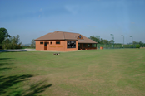

Orchard Ground Committee Meeting Agenda

Thursday 23rd February 2017 The Unicorn

Attendee’s: Mark Cheetham
Duncan Mack Mike Bush
Martyn Waters Louise Sim
Miranda Gregory Colin Antosiewicz
Bob Paine Michael Reilly
Tennis Club Rep Pippa Cheetham
Agenda

- Review of Previous Minutes
- Actions from Previous Minutes
- Casino Night – update and actions
- Matters Arising:
  - Financial / Accounts Update – MB
  - Bookings Update & Maximising usage – Mark
  - New Committee Members
  - Relevant Activity Updates From Key Clubs
- Maintenance Update – CA
- Parish Council Update – MB
- North Field Update - MW
- AOB
- Dates of Future Meetings

